NAME:Rishik JK
REG.NO :192511052

CSA1702-ARTIFICIAL INTELLIGENCE
LAB EXPERIMENT

Experiment 9 – Travelling Salesman Problem

AIM
To write a Python program to solve the Travelling Salesman Problem and find the minimum cost path.

ALGORITHM
- Start the program.
- Store the distances between the cities.
- Select one city as the starting city.
- Generate all possible routes through the remaining cities.
- Calculate the total cost of each route.
- Find the route with the minimum cost.
- Display the best route and minimum cost.
- Stop the program.

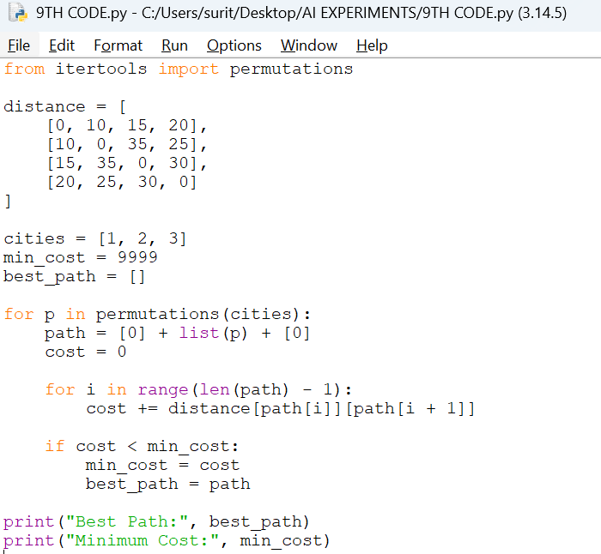

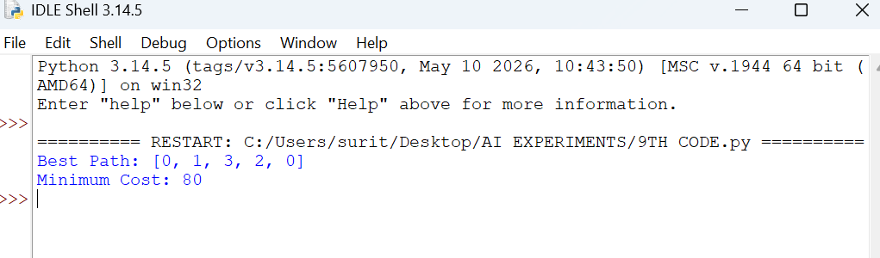

RESULT
Thus, the Travelling Salesman Problem was solved successfully and the minimum cost path was found using Python.

